## Ship segmentation with U-Net

In recent years, deep learning contributed significantly to the advancements of image classification. He.et al [1] managed to build ResNet which surpassed human-level performance on ImageNet [2] for the first time. However, there are many visual tasks requires localization of the target in the image rather than only doing classification. For image segmentation task here, it could be viewed to conduct pixel-level classification for an image. U-Net[3] is a well performing end-to-end convolutional networks originally designed for biomedical image segmentation, it has won the ISBI cell tracking challenge 2015 with a huge margin compared with the second. Here, we use U-Net as our framework to localize ships from the satellite images.

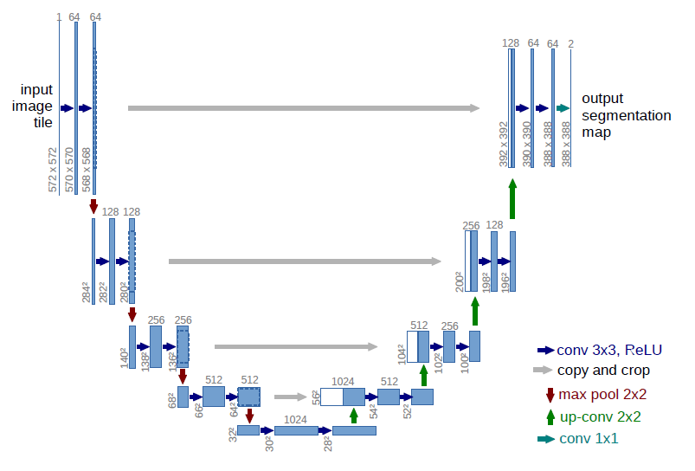

The network architecture is illustrated as Figure.1. The U-Net contains only convolutional layers without fully connected layers. It has two main parts from left to right, the contracting path (or down-sampling) and expansion path (or up-sampling). At the extraction path, the image goes through two 3x3 convolutions with rectified linear unit followed by a 2x2 max-pooling with stride 2 at each stage. Similar to a typical convolutional network, the number of feature channels was doubled after each max-pooling. The expansion path is more or less symmetrical to the contracting path, which also made it similar to an encoder-decoder network. However, it is worth to mention that at each stage of down-sampling, the feature map at the center was copied and transported to its counterpart at the up-sampling stage. The cropping maintained the location information from the input feature to output feature in some degree and also made redemption to the loss of border pixels. In [3], each convolutional layer was implemented with zero padding and hence result in a pixel loss of 2 for each layer. In the end, the output segmentation map has a different size compared with input image. In our project, we set the convolutional layers to have 1 padding and looking to produce exact same size of segmentation map as input satellite image.

Training of our U-Net:

We used batch stochastic gradient descent to train the network

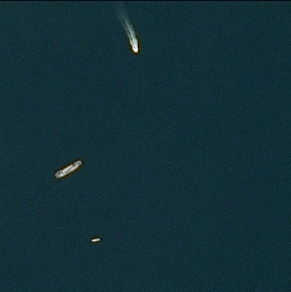

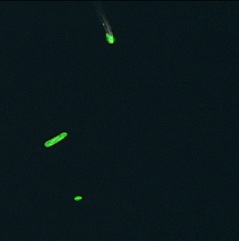

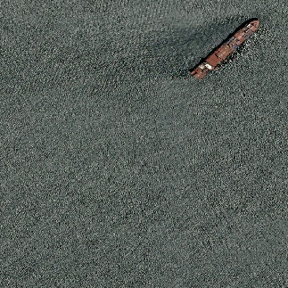

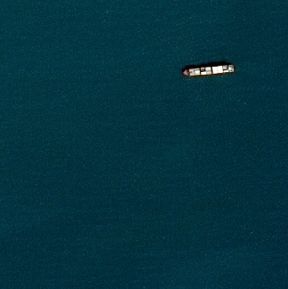

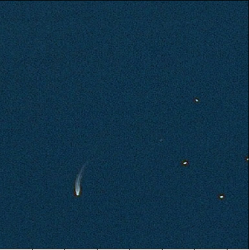

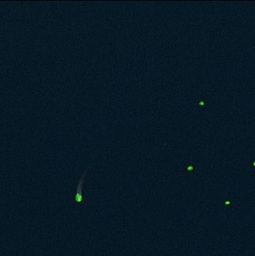

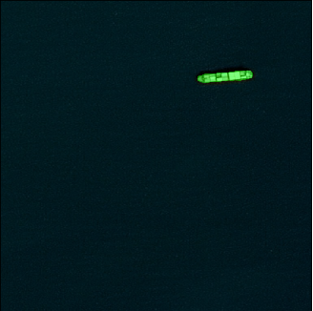

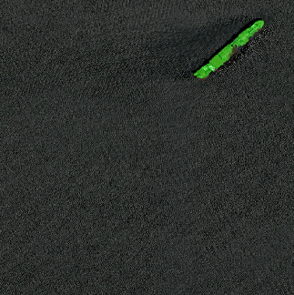

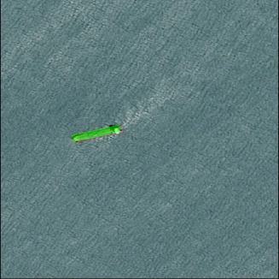

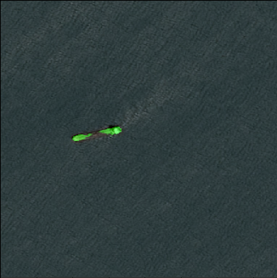

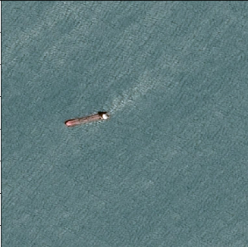

Training of U-Net

介绍U-net结构，

介绍训练方法，过程

训练结果